WHS10P02F01- Template - Safe Work Method Statement

SWMS Details
Company Name: | PEER |  |  | ABN: | Enter text. | Date: | Enter a date.
Contact Person: | Enter text. |  |  | Phone: | Enter text.
Principal Contractor: | Enter text. |  |  | Project/Site: | Enter text.
Person(s) involved in the development of this SWMS: |  | Enter text. |  | Address: | Enter text.
Consultation with workers on SWMS (including HSR if present): |  |  | ☐ Yes ☐ N/A Enter text.
Person responsible for SWMS compliance and review: |  | Enter text. |  | Phone: | Enter text. | Review: | Enter a date.

High Risk Construction Work
☐ HRCW-1 Risk of a person falling more than 3m | ☐ HRCW-7 Work on a telecommunication tower | ☐ HRCW-13 Work on or near energised electrical  installations or services
☐ HRCW-2 Work in an area with movement of  powered mobile plant | ☐ HRCW-8 On or adjacent to a road, railway, shipping  lane or other traffic corridor in use by traffic | ☐ HRCW-14 Temporary load-bearing support for  Structural alterations or repairs
☐ HRCW-3 Work in or near a shaft or trench  deeper than 1.5 m or a tunnel | ☐ HRCW-9 Work in or near water or other liquid that  involves a risk of drowning | ☐ HRCW-15 Work in an area that may have a  contaminated or flammable atmosphere
☐ HRCW-4 Work on or near chemical, fuel or  refrigerant lines | ☐ HRCW-10 Demolition of load-bearing structure | ☐ HRCW-16 Use of explosives
☐ HRCW-5 Tilt-up or precast concrete elements | ☐ HRCW-11 Work in or near a confined space | ☐ HRCW-17 Likely to involve disturbing asbestos
☐ HRCW-6 Work in areas with artificial extremes  of temperature | ☐ HRCW-12 Work on or near pressurised gas mains or  piping | ☐ HRCW-18 Diving work

PPE Required for Task
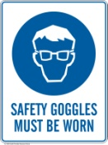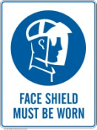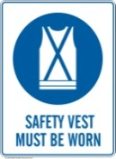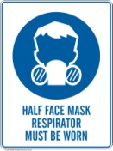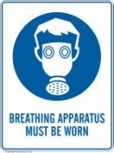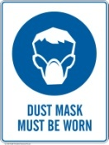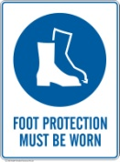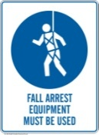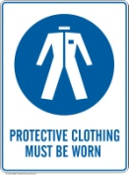  ☐ ☐ ☐ ☐ ☐ ☐ ☐ ☐ ☐ ☐ ☐ ☐ | Other: Click here to enter text.
TASKS
# | Work task | HRCW | Hazards and Risk | Risk Rating | Controls | Residual Risk

- Work must be performed in accordance with this SWMS.
- This SWMS must be kept and be available for inspection until the high-risk construction work to which this SWMS relates is completed.
- If the SWMS is revised, all versions should be kept.
- If a notifiable incident occurs in relation to the high-risk construction work in this SWMS, the SWMS must be kept for at least 2 years from the date of the notifiable incident.

NAME OF WORKER | WORKER SIGNATURE | DATE

