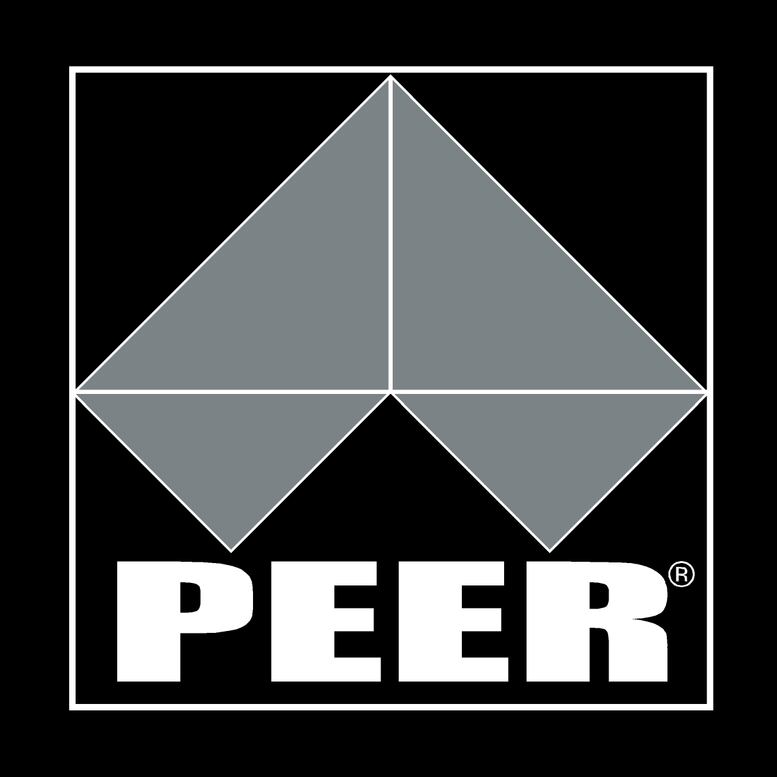
RECOGNITION OF PRIOR LEARNING (RPL) INFORMATION GUIDE

WHAT IS RPL?
Recognition of Prior Learning (RPL) is a term that includes Recognition of Current Competencies (RCC) and Skills Recognition. All of these terms refer to the recognition of competencies that people currently have regardless of how, when or where they obtained their knowledge/skills. The competencies may have been gained through any combination of formal or informal training and education, work experience or general life experience and overseas experience.
When RPL is undertaken and is successful it will impact on the duration of course or qualification being studied and may affect any funding that is being provided for the program. Generally speaking, the completion time for the course or qualification should be reduced. The amount of reduction will depend on how comprehensive and successful the RPL achievement is.

BENEFITS OF RPL
There are numerous benefits or advantages to a learner in respect of a successful RPL application, including but not limited to:
- Avoiding the duplication of unnecessary training and learning in areas that the applicant is competent. It means that the successful applicant learner only completes the units or modules that are new and challenging
- Potentially accelerating the process of completion of a qualification, or alternatively resulting in a reduced course workload
- Recognising that the applicant is entering the course with numerous skills and an amount of underpinning knowledge
- Developing a permanent and portable record of their competencies and achievements
- Even in the event of being unsuccessful in the application of recognition, the RPL process will assist in clarifying competencies and discrepancies in knowledge and skill to enable effective tailoring of individualised learning programs

WHAT IS INFORMAL STUDY?
Informal study is where the training is not Nationally Accredited and is delivered outside a formal learning environment such as an education or training facility. The learning can include:
- Training delivered within the workplace
- Product training in the workplace by the manufacturer which covers specifications, installation, and/or use etc
- Seminars, workshops or training events delivered by industry or professional associations or groups
- Community training programs/courses.

WHAT IS FORMAL STUDY?
Formal study occurs normally in accredited education and training facilities such as TAFE, Registered Training Organisations, and Universities etc. This study leads to Nationally Accredited results where Qualifications or Statements of Attainment are awarded.

WHAT IS A UNIT OF COMPETENCY?
Qualifications are made up of a number of core and elective Units of Competency. Core units must be completed and electives are a group of units from a specified number that are selected to complete the total number of units required.

Each unit is made up of Elements. The Elements are smaller chunks of the whole unit e.g. in Occupational Health & Safety the unit would be Apply Occupational Health Safety regulations, codes & practices in the workplace, an Element of that unit would be Follow Safe Work Practices.

A Unit of Competency is an individual unit that identifies the industry standard of performance for knowledge and skills required for the job tasks associated with that unit in the workplace. An individual unit of competency can be assessed and recognised.

Training Package information is available at www.training.gov.au

WHAT DOES “COMPETENCY” MEAN?
Competency is when a person:
- Can perform the specific tasks in the unit required to do the job to a level that meets standard set by industry
- Knows why the tasks need to be completed
- Follows and understands the correct procedure/process to complete the task safely and efficiently
- Uses the correct resources safely and in the right manner to complete the task
- Knows how to correct errors and mistakes
- Knows and can use the same skills across different work situations.

During an RPL assessment the assessor collects evidence to assure the applicant:
- Holds the necessary knowledge
- Holds current knowledge and skills
- Can apply that knowledge successfully in the workplace
- Can perform tasks to the level set out in the industry standards

To be assessed as “Competent" the assessor will determine that the required skills, knowledge and attributes are at the level and standard required.

In order for an assessor to determine if a person is competent or not against the standards of the Australian Quality Framework Nationally Accredited Courses and Training Packages the person needs to provide sufficient evidence.

Evidence may take a variety of forms including but not limited to:
- Observation of practical tasks
- References from past employers
- Testimonials from clients
- Work samples – products of work that you have completed
- Presentations – you may be observed giving a presentation
- Documents – relevant qualifications, transcripts, and project plans etc
- Video and/or audio taped evidence showing you completing tasks
- Log book records of Australian work placement
- Trades Test outcomes
- VETASSESS minimum gap training for OTSR holders

OTSR – SKILLS ASSESSMENT FOR LICENSING PURPOSE
Australia has a complicated licensing system for trade workers which vary from state to state. However, all states and territories recognise an Offshore technical Skills record (OTSR) as evidence to issue a provisional trade work permit or licence.
The OTSR enables a person to apply for a provisional trade license to any trade licensing regulator, on arrival in Australia, so they can commence work under general supervision in their trade. The person must also enrol with an Australian Registered Training Organisation to complete required gap training within a 12 month period.
If you are already in Australia and are seeking to work in your trade you can also now apply to have your skills assessed in Australia towards and Offshore Technical Skills Record. The only requirement is that you have undertaken you technical trade training outside of Australia and you have never worked in the trade in Australia before
These types of skills assessment can only be undertaken by a TRA approved Registered training Organisation.
Please note: Gap training will still be required

WHAT IS “GAP” TRAINING?
On completion of the RPL assessment the assessor may decide that further training is required. This is known as ‘gap’ training and the assessor will discuss an individualized training plan.

If you hold a VETASSESS OTSR you will need to successfully complete the Australian Minimal Context Gap Training.

SELF ASSESSMENT FOR RPL
Self assessment is where you investigate whether you have enough evidence to achieve RPL and create a personal portfolio of that evidence.

Examples of evidence you might provide are:
- Relevant course certificates, statements of attainment or statements of attendance for the training undertaken. If the training was not-accredited copies of the course information will need to also be provided.
- Samples of work. These can be photographs or videos, written documents or other.
- Letters from current or ex employers that provide confirmation of claims.
- Letters from clients that provide confirmation of claims.
** Please note that a letter that states ‘this person worked for me and did a good job’ will not be accepted. The letters need to address the units of the course or give a detailed indication of the work undertaken.
- An on-the-job assessment record.
- Performance Evaluation report from current and/or previous workplaces.
- A job description signed by the employer.
- Occupational licenses.
- Copies of completed assignments.
- VETASSES documents
- Log Book records of Australian Work Placement; containing dates, times and places you have completed outlined tasks

Please note that resume or curriculum vitae are not evidence. However, please enclose an up to date resume or CV (including paid and unpaid work, community involvement etc) as it will provide the assessor with a basis to conduct an interview.

The best evidence that can be submitted needs to be:

- Current – in other words does the evidence demonstrate the skills and knowledge required to meet current performance requirements of the unit;
- Valid – means, does evidence relate directly to the unit of competency; does it demonstrate the relevant skills and knowledge for the unit and is it appropriate to the level required by the competency;
- Authentic – each piece of evidence can clearly be identified as your own work, dated and referenced; copies of documents, qualifications, references, licenses etc certified documents; can your verbal and written claims be verified by a credible third party or supported by documented evidence;
- Sufficient – does the evidence include all the critical tasks and knowledge in the unit of competency, prove they have been performed over a period of time and in different situations and is there enough different forms of evidence.

In the case where the portfolio does not satisfy the requirements of competency for a unit, additional or supplementary evidence can be undertaken. This type of evidence may include:
- An assessment review or interview;
- An oral or written questionnaire;
- Practical demonstration on or off-the-job.
- Completion of a profiling log book

THE USE OF WORKPLACE DOCUMENTATION
When using workplace documentation for providing evidence of competency make sure that the documents you use is relevant to the units you are applying for. Think of the reasons why this workplace document is used and how it relates to your RPL application.

For example you would use a JSA (Job Safety Analysis) to provide possible evidence of you;
- Completing and maintaining documentation
- Apply OHS policies and procedures in the workplace
- The job task that you completed
- Documenting occupational hazards and risk in the workplace

The types of workplace documentation you can use to assist in providing evidence of competence include but are not limited to:

- Diagrams and sketches
- Instructions issued by authorized organizational or external personnel on job tasks you completed
- Log Book records of Australian Work Placement
- Material Safety Data sheets
- Memos
- Written communication and graphical instructions
- Work schedules, plans and specification
- JSA and SWIMS
- Documented Tool box meetings you attended
- Induction documentation
- Purchase requisitions

THE USE OF PHOTGRAPHIC EVIDENCE AND OR VIDEO EVIDENCE
As part of the evidence you can provide, video evidence of you completing tasks in the workplace or simulated work environment. When providing such evidence you must adhere to the following guidelines.

- It is essential that you obtain written consent from anyone that is directly in the video with you. This written consent must be submitted with your video evidence. A Copy of a Consent Form is provided within the application document.
- You must conduct the video evidence in the workplace completing job tasks. Talk to your employer or supervisor for permission.
- Video submission must be submitted on a USB or DVD.
- Filming can be of home standard, you do not need to have it professionally produced.
- Keep the recording simple and clear and focused on yourself completing the job task.
- The video must be a recording of you completing job tasks.
- Clearly identify (via a short introduction) yourself as the student and introduce what you are about to demonstrate.
- Once you have completed you video evidence, please review the video to identify whether the information reflects your current competency level and level of understanding. “Have you demonstrated clearly the job you have just completed from start to finish?” “Is this a true representation of the task you had to perform?”
- Once the video is produced, check the sound and visual quality is acceptable. If the assessor cannot see you or hear you or clearly see the job task you are completing, then it may affect your RPL assessment outcome.
- PEER does not return submissions. They remain the property of PEER for RTO compliance. So, please keep copies of all evidence.

THE USE OF E-PROFILING RECORDS THE AUSTRALIAN WORK PLACEMENT AS EVIDENCE
The E-Profiling is for recording workplace experience. The E-Profiling is to be documented over a period of time and record the on the job experience you have in your field of application.
As part of the OTSR process, it is compulsory for the OTSR holders to undertake a period of supervised employment or work placement to be eligible for the Nationally Accredited Qualification for you particular application for skills recognition.

THINGS TO BE CONSIDERED TO HELP YOU PREPARE FOR RECOGNITION – TIPS & HINTS
Being prepared will save time and make the RPL process less stressful. Things you should consider before applying for RPL are:

- Other information that will help at the interview i.e. be prepared to talk about job roles, work history, sports and hobbies, community involvement etc. If it isn’t included in the resume or CV then include it or make notes to bring to the interview.
- As only copies of evidence are being provided initially remember to bring original evidence to the interview so it can be sighted and the copies can be authenticated by the Assessor as to be true and correct copies.
- Ask work, sporting, community and other colleagues to help brainstorm possible evidence to provide.
- Does your current employer support your professional development and how will this impact on your RPL and study. What time will you have available and when.
- Would it be appropriate for the assessor to contact current and previous workplaces to have skills validated?
- Consider other people who could confirm skill levels. If it is not appropriate for the assessor to contact one or more current or previous employers, is there a direct supervisor within the past 18 months or so who would be able to validate skills, or community contacts or clients who can attest to skill level?

Carefully consider and search out all and any Certificates or Statements of Attainment or attendance that have been achieved / given. All certificates will be considered in the RPL or Skill recognition process.

WHAT TO INCLUDE IN YOUR APPLICATION & PORTFOLIO
This is a checklist of the things you need to include when returning your application:

Section 1 – Application
- Completed Application Form;
- Application Fee;
- Resume or CV (remember this is not evidence)

Section 2 – Portfolio
- Completed Evidence Checklist.
- Contact names and details of people who the assessor can contact to validate your skills.
- Copies of all of your evidence.
DO NOT include original evidence as we do not guarantee the return of these documents.
- Each piece of evidence must have a notation on it which identifies the unit the evidence applies to, or, number each piece of evidence and attach a ‘Evidence Index’ that identifies the number, the name of the document and the unit it relates to. A Copy of an APPENDIX 1: EVIDENCE INDEX is provided within the application document.

OUTCOMES OF RPL
There are four possible outcomes from an RPL assessment:
- A ‘Statement of Attainment’ for the units that you have been assessed as competent for. These may be used as credit toward gaining a full or other qualifications;
- A full qualification is recognized;
- ‘Gap’ or ‘bridging’ training is determined for some or all of the units applied for or the qualification;
- The evidence provided does not align correctly or sufficiently with the course requirements resulting in no formal recognition by the assessor.

WHAT IF THE RPL APPLICATION IS UNSUCCESSFUL?
If the RPL application is unsuccessful, a re-evaluation may be applied for.

If RPL is not granted after re-evaluation the decision can be formally appealed. The assessor will assist you with the Appeals Process.

PEER VEET must clarify with the student upfront the number of opportunities to re-submit an RPL application.

RECOGNITION OF PRIOR LEARNING MODEL
Candidate Appeals decision
No

Candidate successful
Access additional evidence submitted by candidate and make decision
Candidate gathers additional evidence and submits according to agreed Action Plan
Assessor liaises with candidate, indentifies gaps, recommends Action Plan and outlines resubmission process and timeframe
3. Enrolment process includes supplying the full RPL Kit
No

8. RPL is granted, record keeping complete and qualification or Statement of Attainment issued
Yes

Candidate successful
7. Assessor makes assessment decision and provides feedback to the candidate
6. Assessor reviews evidence which includes an interview or Question/Answer with the candidate
5. Evidence is submitted to the assessor
4. Candidate and assessor discuss and agree on ways to gather evidence
1. Pre Enrolment Information Provided
2. Guidance provided to candidate (this could include self assessment)
No

Candidate advised RPL process not suitable and other options discussed
Suitable for RPL
Candidate Appeals decision
Evidence Process of Assessment
Decision making,
Issuing credentials,
Further support/follow up
Provide Information

Yes

RPL is not approved and candidate advised accordingly

FEES & WHAT THEY INCLUDE
There is an initial application of your RPL. This cost includes the assessor to assess whether you are suitable to continue with your RPL application. This initial cost is non refundable.
If you have been deemed suitable to complete and proceed with the RPL process there will be an additional fee. This cost includes you completing any trades test, wiring regulation assessment, a capstone assessment, gap training and assessment and assessment of your “On the Job” experience (if applicable).
If you are required to do any “gap’ training and assessment there will be an additional cost, as per the unit price list. Please consult with the Up skilling Administration Staff to confirm the unit price list
Please Note: Fees do not attract GST, and are subject to change. At the time of application you must confirm the current fees. Statement of Attainment will not be issued until all fees are paid in full.
If you are on a “Contract of Training” with an employer, fees do not apply.

GENERAL ENQUIRES
For general enquires please contact PEET VEET UPSKILLING SERVICES on 08 8348 1200 or email upskilling@peer.com.au

WHERE TO SUBMIT APPLICATION
Please send you application via registered post to:

PEER VEET UPSKILLING SERVICES
PO BOX 2160 PORT ADELIADE BC
PORT ADELAIDE 5015

